CoolMonkey Tap 2 Earn Clicker Game

Telegram Mi ni A pp + AP I + Bot

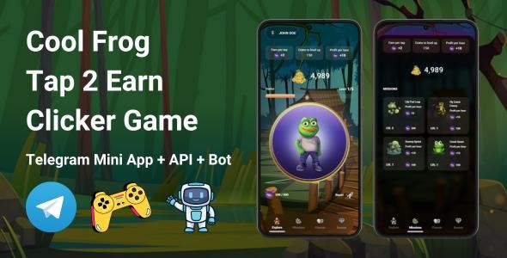

Summary

What is CoolMonkey Tap2Earn? .......................................................................................... 3

How to setup CoolMonkey game frontend........................................................................... 4

How to setup CoolMonkey API ............................................................................................ 5

How to setup CoolMonkey Telegram bot............................................................................. 7

How to run the game locally ............................................................................................ 8

How to add/customize levels, missions and tasks ........................................................... 9

What is CoolMonkey Tap2Earn?

**CoolMonkey Tap2Earn** is an exciting and addictive Telegram mini app clicker game where tapping isn't just fun—it's rewarding! Step into the world of CoolMonkey, where every tap brings you closer to earning coins, leveling up, and dominating the **leaderboard.**

**Features include:**

• **Tap to Earn Coins**: Tap your way to wealth by earning coins with every click.

The faster you tap, the more you earn!

• **Buy Boosters**: Supercharge your tapping power with a variety of boosters.

Maximize your earnings and dominate the competition.

• **Refer Friends**: Invite your friends to join the fun and get bonus coins for each referral. The more friends you refer, the richer you become!

• **Complete Tasks**: Take on daily tasks and challenges to earn extra coins. Each

task completed brings you closer to your next big reward.

• **Upgrade Missions**:

1. Invest in upgrades to earn coins passively, even when

you’re not tapping.

1. **In Upgrade Missions, add a Section called**: Tycoon.
2. **In Tycoon Section**, Here, there going to be packages with different TON Prices, to be bought by users using TON and they get more points earned per hour.

NOTE:

1. Enable the admin to create these packages with the following setting;
2. **Package Name;** Name of the Package
3. **Image;** Image of the package
4. **Description;** Package Description
5. **Value in TON Coin;** Number of Ton Coins to be paid.
6. **Points Per Hour;** Are the number of Points Per Hour one will get. This will increase one’s per hour.
7. **Tycoon TON Wallet Address;** Is the TON Wallet Address that will be set by the admin, where the TON Coins will be sent when the user buys the package.
8. Enable the admin to add as many packages as possible.

**Create an inapp purchase Section:**

1. For Telegram “Stars” Donation, in order for users to get more Points.

NOTE:

1. Enable the admin to create these packages with the following setting;
2. **Number of Stars;** Are the number of Telegram “Stars”
3. **Description;** Package Description
4. **Value in TON Coin;** Number of Ton Coins to be paid.
5. **Points Per Hour;** Are the number of Points Per Hour one will get. This will increase one’s per hour.
6. **Telegram “Stars” Donation TON Wallet Address;** Is the TON Wallet Address that will be set by the admin, where the TON Coins will be sent when the user buys the Telegram “Stars” Donation.
7. Enable the admin to add as many packages as possible.

• **On Home Page**: Add a Button called; “**Airdrop**”

It is a section where there is;

**A title called; Airdrop Eligibility Criteria**

**Show this Information to the user:** To qualify the airdrop, you must do the following;

1. **Connect Wallet, that is TON Wallet** - A user must connect to TON
2. Boost TON Network with 0.5 TON – **Here, a user must connect to TON and make a 0.5 TON transaction.**

**Note: Create a Boost TON area: In this area,** Enable the admin to insert a TON wallet address where the **Boost TON Network with 0.5 TON** will be sent when the user makes that transaction, and the section where the admin will assign the amount of points to be awarded to the user who has done this transaction.

1. Points Balance.
2. Join our Telegram Community Channel. **Note: Enable the admin to set this in the Admin Dashboard.**
3. Follow and re-tweet our Twitter (X). **Note: Enable the admin to set this in the Admin Dashboard.**
4. Follow and like our Youtube. **Note: Enable the admin to set this in the Admin Dashboard.**
5. Follow and like our Tiktok. **Note: Enable the admin to set this in the Admin Dashboard.**

Let your Monkey work for you around the clock!

• **Level Up**: Use their point to level up and unlock new features, bonuses, and more powerful upgrades.

• **Leaderboard**: Compete against players worldwide to claim your spot at the top. Enable a player/ user to create his/her own group if he/she has a balance of 100,000,000 Points.

Show everyone who the ultimate **CoolMonkey** is!

**Note:** In the Tasks sections, Create Two Sections.

1. **Live Tasks:** Put all uncompleted Tasks here.
2. **Complted Tasks:** Put all completed Tasks here.

Whether you're in it for fun, competition, or just to see your name on the leaderboard, **CoolMonkey Tap2Earn** is the game for you!

How to setup CoolMonkey game frontend

First let’s setup the frontend of the game, this is the telegram mini app that the bot will open.

1. Open your project in VS Code or any other IDE

2. Navigate to the `CoolMonkey` folder

3. Open the `.env` file

4. Set your domains where you will host the api and frontend, and set your telegram

bot’s url (how to create a telegram bot: [https://core.telegram.org/bots/tutorial)](https://core.telegram.org/bots/tutorial)

5. Open the terminal while located in the `CoolMonkey` folder

6. Run `npm install`

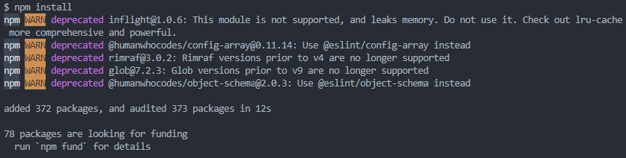

7. After installation, run `npm run build`

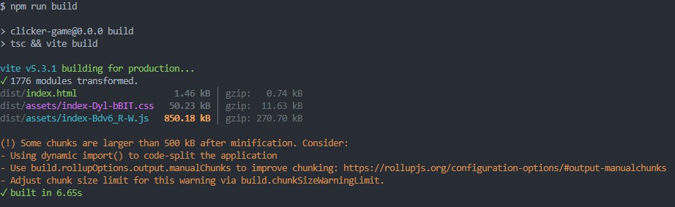

8. If you want to run the game locally, you need to run `npm run dev`, otherwise you need to put the contents of the generated `dist` folder on your hosting

How to setup CoolMonkey API

**Next let’s setup the API of the game, this is where the frontend makes requests to get and save data of the game.**

1. Open your project in VS Code or any other IDE

2. Navigate to the `api` folder

3. Open the `.env` file

4. Set your database login data (username, password), APP_URL and

APP_STORAGE_URL ( should be the domain of your api)

5. Open the terminal while located in the `api` folder

6. Run `composer install` (you can download composer from here:

[https://getcomposer.org/)](https://getcomposer.org/)

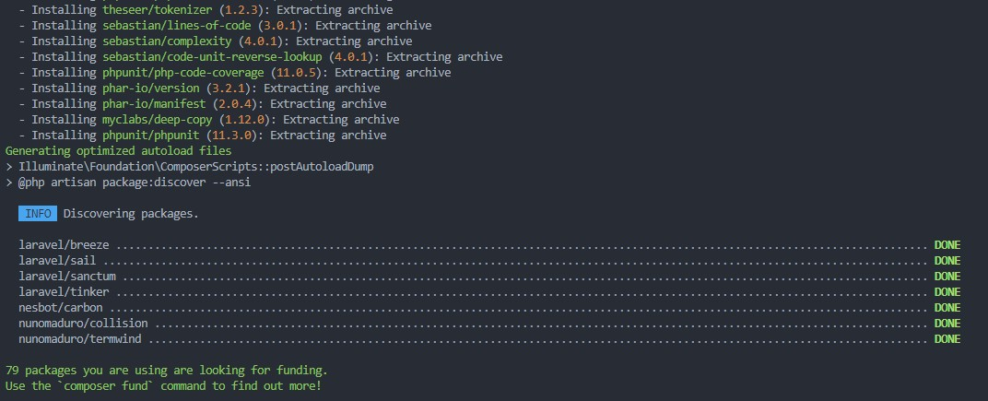

7. Make sure you have a mysql server running on your hosting or local environment

8. Run `php artisan migrate` (this will create the database)

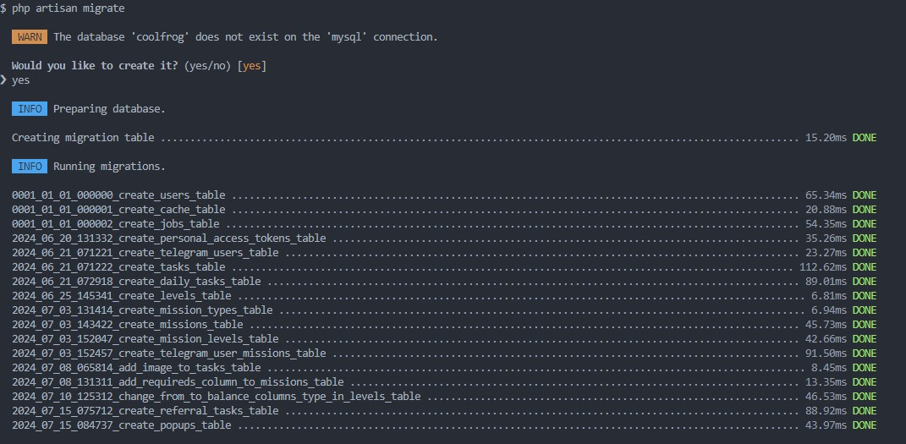

9. Run `php artisan db:seed` (this will seed the database with data – levels, missions etc.)

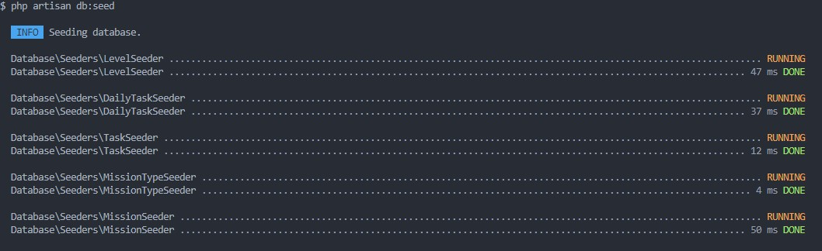

10. Run `php artisan key:generate`

11. Run `php artisan storage:link`

12. Now your API is ready to go, if you want to run it locally run `php artisan serve`, otherwise you need to put this code on your hosting

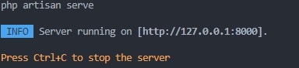

How to setup CoolMonkey Telegram bot

**Last but not least, let’s setup the Telegram bot of the game so we can actually access it through Telegram.**

1. Open your project in VS Code or any other IDE

2. Navigate to the `bot` folder

3. Open the `.env` file

4. Setup your APP_URL (this is the domain of the frontend) and Telegram bot token, which you get from Bot Father on Telegram after creating it.

5. Open the terminal while located in the `bot` folder

6. Run `npm install`

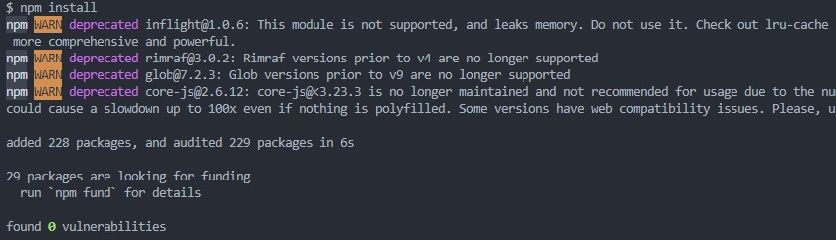

7. After installation, run `npm run build`

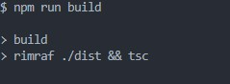

8. If you want to run the bot locally, you need to run `npm run dev`, otherwise you need to run the index.js file located in the generated `dist` folder on your hosting server (this can be done with pm2: [https://pm2.keymetrics.io/)](https://pm2.keymetrics.io/)

That is all. Now you should be able to access your bot by sending the `/start` command to your bot and pressing the Play Game button!

How to run the game locally

Note that you can run the game locally (without bot, just game and api), but if you want

it to be launchable through telegram, the game needs to be hosted on domain with SSL (https).

1. Setup your API as shown here

2. Setup your frontend as shown here

3. Next thing is to set the environment variables (in .env file) in your frontend to your local URLs as shown below:

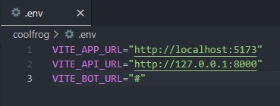

You can leave the VITE_BOT_URL empty, since we won't be using the bot locally.

Also please note, that you may have different ports, change them accordingly.

4. After you have set up both frontend and API, you should be able to access it by visiting the frontend URL in your browser.

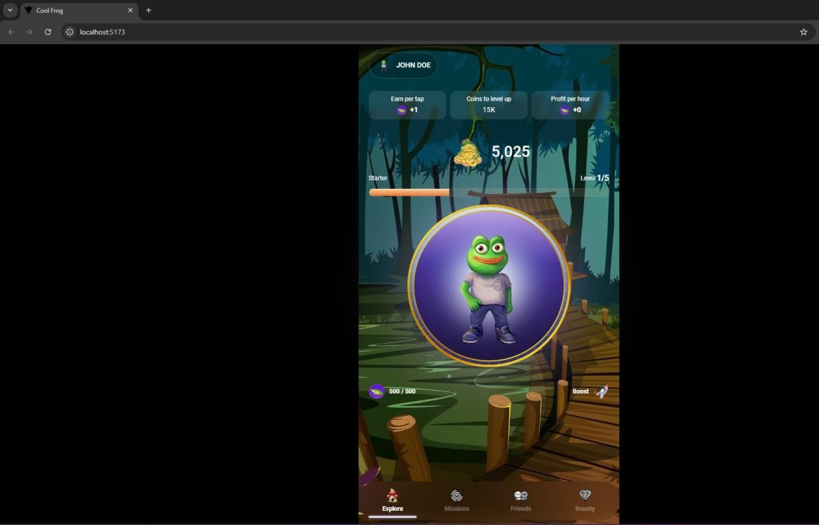

How to add/customize levels, missions and tasks

The customization/adding of levels, missions and tasks is done in the API, because they are saved in the database. So, if you want to change them, please follow these steps:

1. Open your project in VS Code or any other IDE

2. Navigate to the `api` folder

3. Open the `database/seeders` folder, there you will have all the database seeder files

4. To add missions, open the `MissionSeeder.php` file, it should look like this:

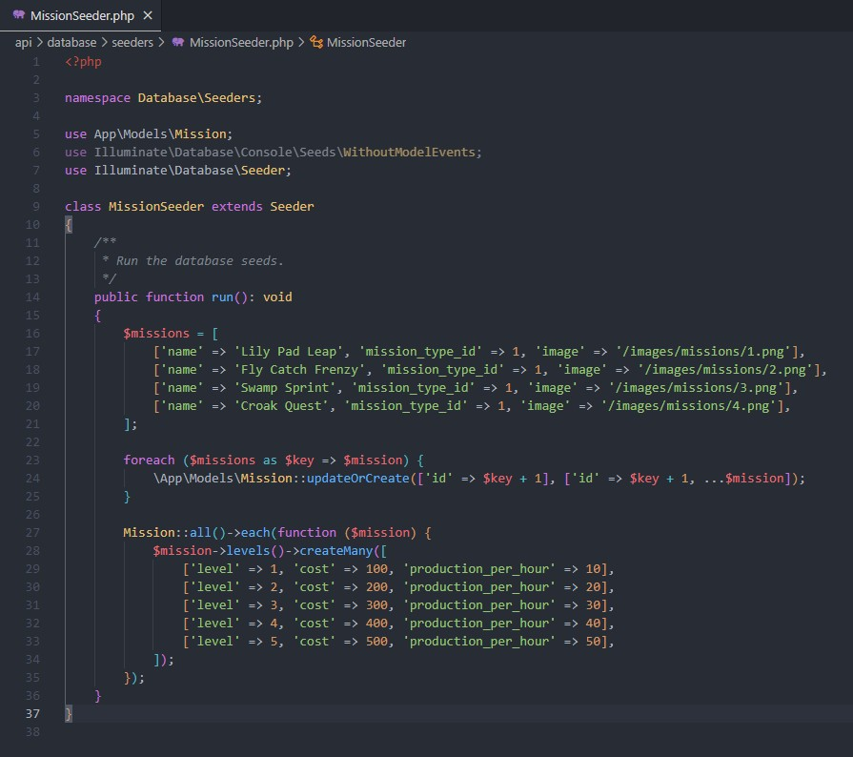

5. Following the provided example, you can add your own missions and customize their level cost and production per hour.

6. If you want to add levels, open the `LevelSeeder.php` file, it should look like thi s:

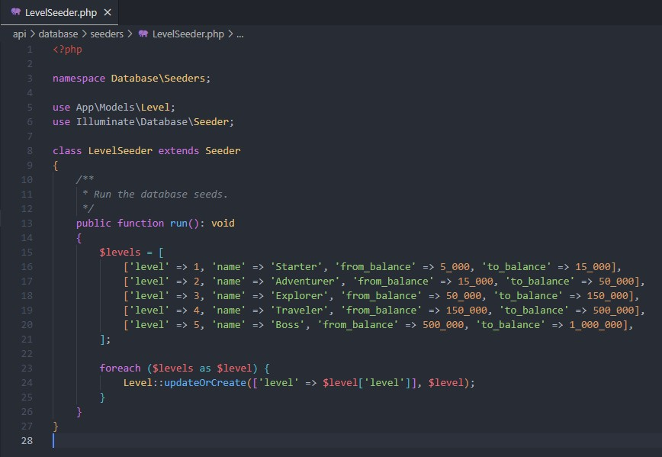

7. Following the provided example, you can add your own levels and customize their required balance.

8. If you want to add tasks, open the `TaskSeeder.php` file, it should look like this:

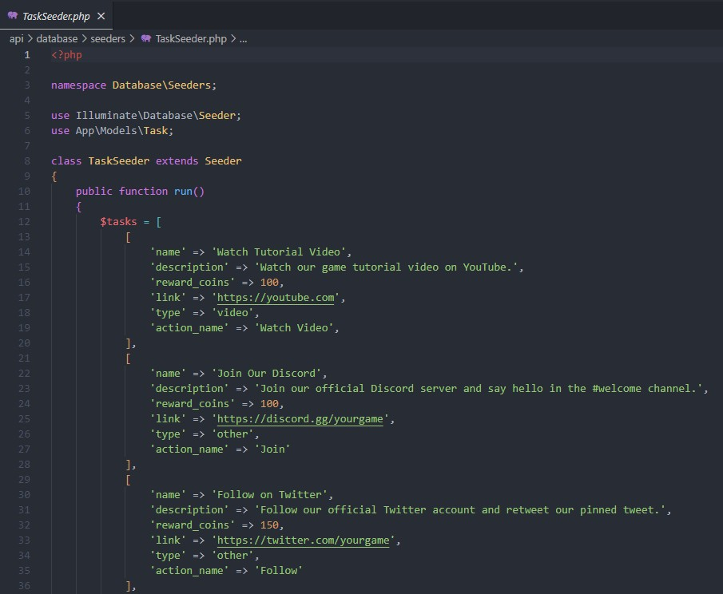

9. Following the provided example, you can add your tasks and customize their rewarded coin amount.

10. The same goes for referral tasks (ReferralTaskSeeder.php), daily tasks (DailyTaskSeeder.php), popups (PopupSeeder.php) and mission types (MissionTypeSeeder.php).